SIMATS ENGINEERING
SAVEETHA INSTITUTE OF MEDICAL AND TECHNICAL SCIENCES
NAME:A SHIVA SHANKAR REDDY
DATE:29/09/2026
LAB EXP: 1 TO 5
Dept. Name:CSE -AIML
Course Code/Course Name: DSA06 /Data Handling and Visualization

Set 1: Monthly Sales Data
Dataset: Monthly Sales
1. Create a line chart to visualize the monthly sales. Label the axes and title the chart appropriately.
2. Generate a bar chart to display the top-selling products for the year. Label the chart elements.
3. Develop a scatter plot to explore the relationship between advertising budget and monthly sales.
Explain the insights drawn from the scatter plot.
4. Build an interactive dashboard combining the line chart and bar chart to allow users to explore sales
data interactively.
Aim
To create a line chart using R to visualize monthly sales and label the axes and title.
Algorithm
- Start the program.
- Create a dataset containing months and sales.
- Store the data in variables.
- Use the plot() function to create a line chart.
- Label the X-axis and Y-axis.
- Add a suitable title.
- Display the chart.
- Stop.

R Program
R
month <- c("January", "February", "March", "April", "May")
sales <- c(15000, 18000, 22000, 20000, 23000)
plot(sales,
type = "o",
col = "blue",
xaxt = "n",
xlab = "Month",
ylab = "Sales ($)",
main = "Monthly Sales Analysis")
axis(1, at = 1:5, labels = month)
grid()

Sample Input
January 15000
February 18000
March 22000
April 20000
May 23000
Sample Output
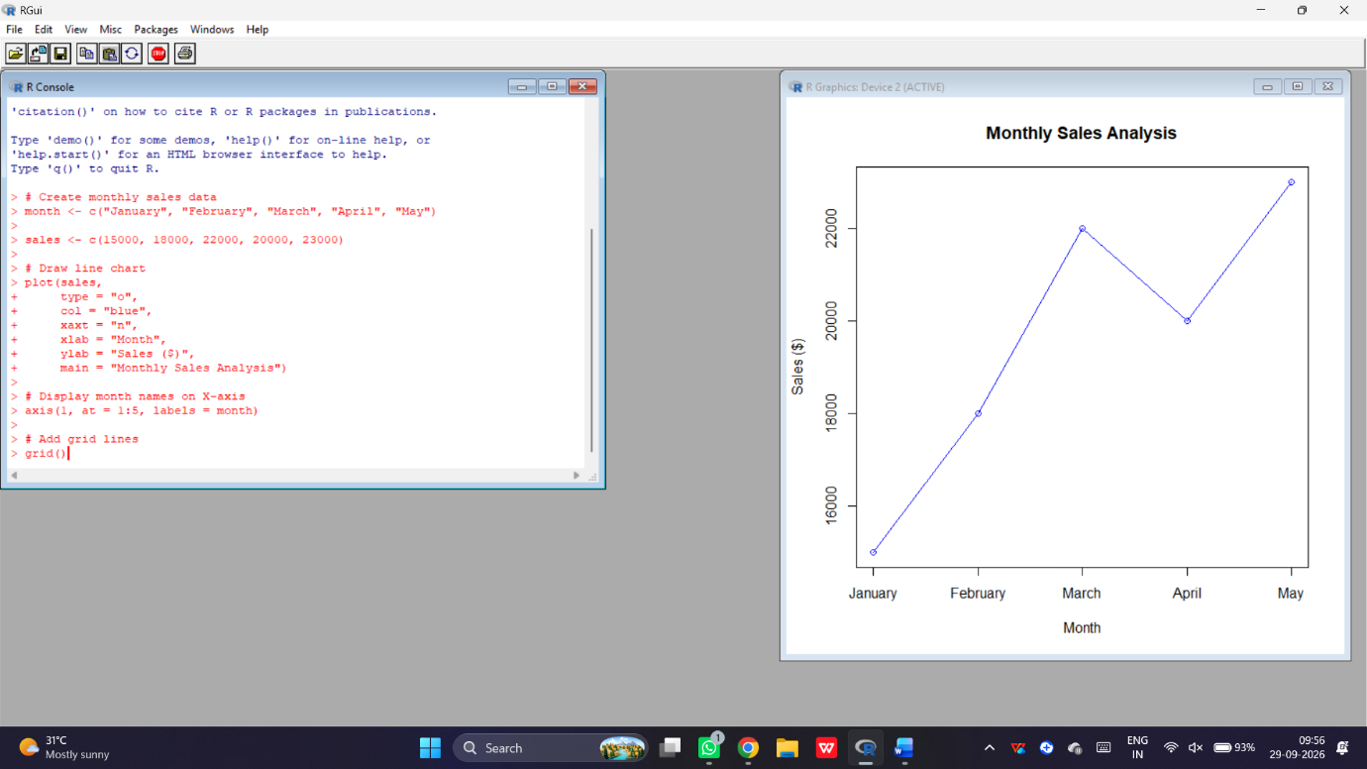
Expected observation:
- Sales increase from January to March.
- Sales decrease slightly in April.
- May records the highest sales of $23,000.
Result
Thus, the monthly sales line chart was successfully created using R.

Experiment 2: Bar Chart for Top-Selling Products
Aim
To create a bar chart to display the sales of different products using R.
Note: The PDF does not provide product-wise sales values for Set 1. The following values are illustrative sample data for practicing the program.
Algorithm
- Start.
- Create product names and sales values.
- Use the barplot() function.
- Set chart title and axis labels.
- Display the bar chart.
- Stop.
R Program
product <- c("Laptop", "Mobile", "Tablet", "Headphone", "Watch")
sales <- c(50000, 80000, 30000, 20000, 40000)
barplot(sales,
names.arg = product,
col = "skyblue",
main = "Top Selling Products",
xlab = "Products",
ylab = "Sales ($)")
grid(nx = NA, ny = NULL)
Sample Input
Laptop 50000
Mobile 80000
Tablet 30000
Headphone 20000
Watch 40000
Sample output:
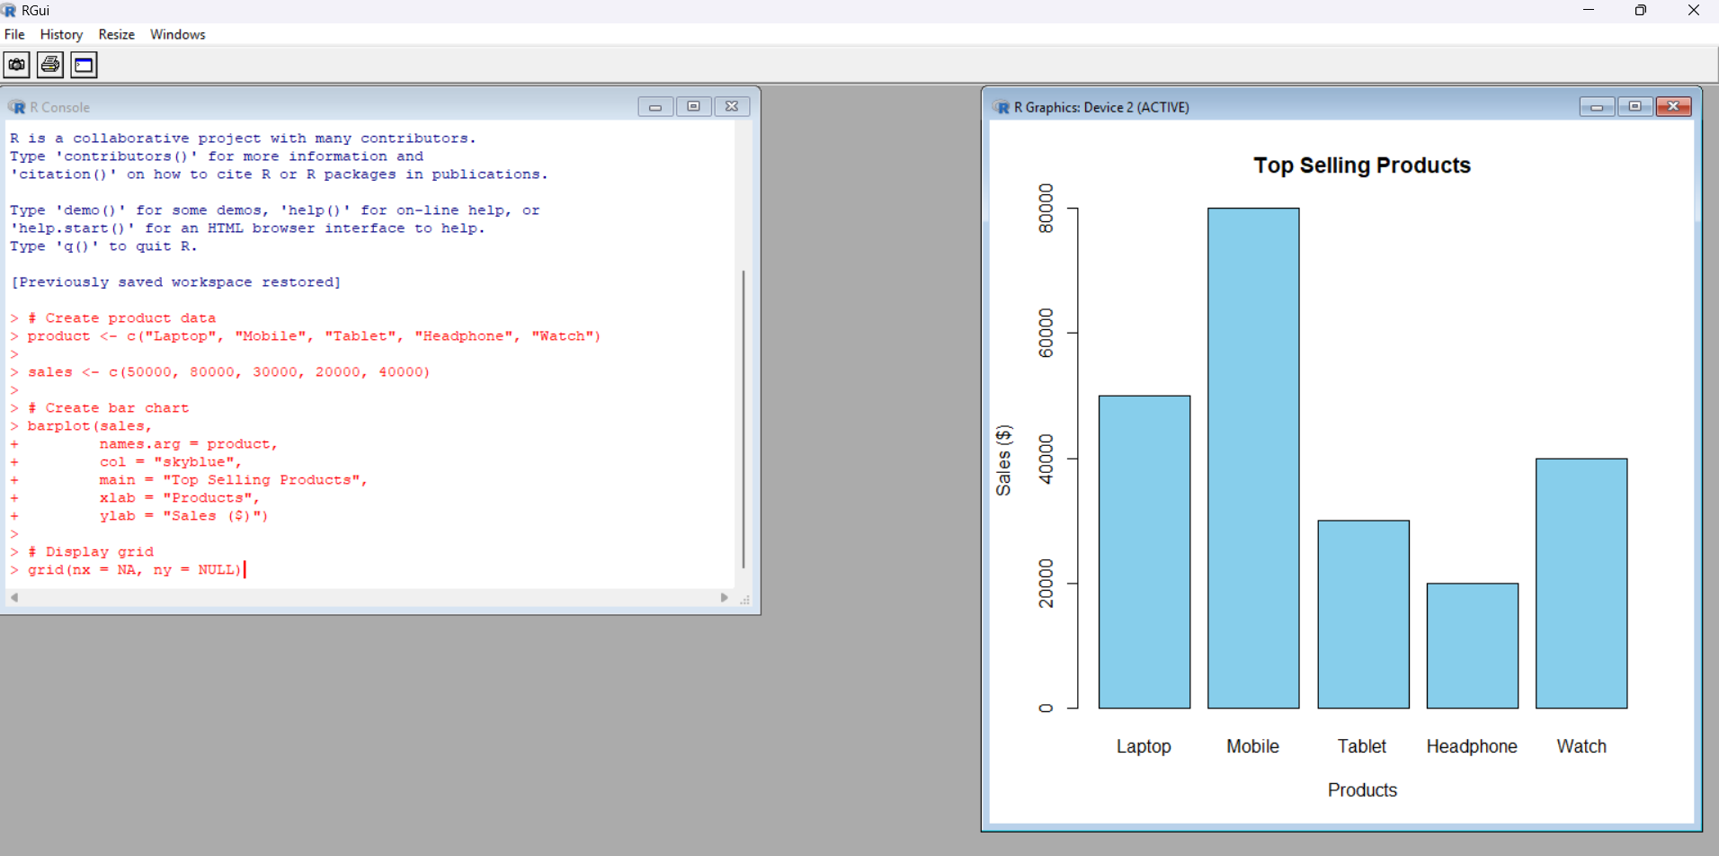
Expected observation: Mobile has the highest sales of $80,000.
Result
Thus, the bar chart showing product-wise sales was successfully generated.
Experiment 3: Scatter Plot – Advertising Budget vs Monthly Sales
Aim
To create a scatter plot using R to analyze the relationship between advertising budget and monthly sales.
Algorithm
- Start.
- Create advertising budget and sales data.
- Use plot() to draw a scatter plot.
- Label both axes.
- Add a title.
- Use cor() to calculate correlation.
- Interpret the relationship.
- Stop.
R Program
ad_budget <- c(2000, 3000, 4000, 3500, 5000)
sales <- c(15000, 18000, 22000, 20000, 23000)
plot(ad_budget, sales,
pch = 19,
col = "red",
xlab = "Advertising Budget ($)",
ylab = "Monthly Sales ($)",
main = "Advertising vs Sales")
abline(lm(sales ~ ad_budget), col = "blue")
cor(ad_budget, sales)
Sample Input
Advertising Budget: 2000 3000 4000 3500 5000

Sales: 15000 18000 22000 20000 23000

Sample Output
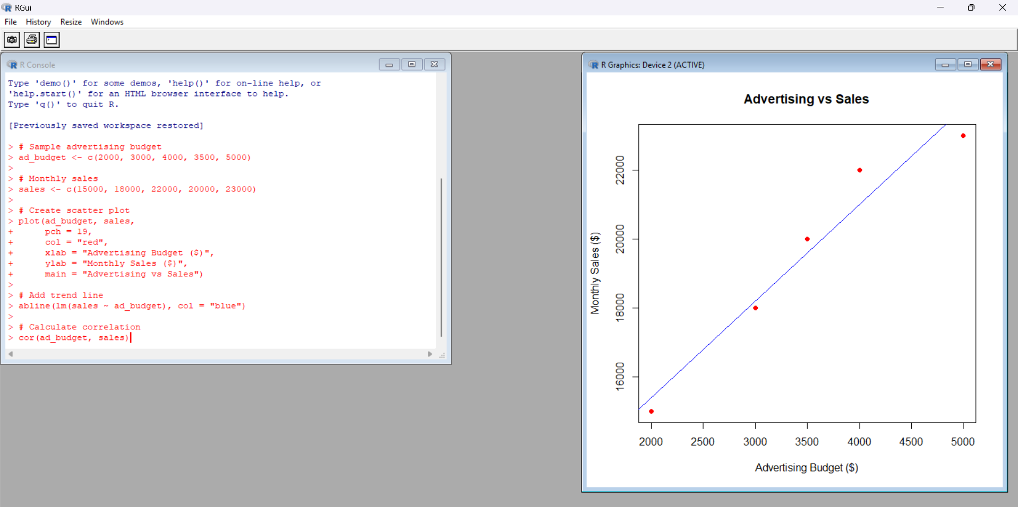
Expected observation:
- The points show a positive relationship.
- Sales generally increase as advertising budget increases.
- The correlation is approximately 0.97 for this illustrative dataset.
Result
Thus, the scatter plot was created and the relationship between advertising budget and sales was analyzed.

Experiment 4: Interactive Sales Dashboard
Aim
To develop an interactive dashboard using R Shiny by combining a line chart and bar chart for sales data.
Algorithm
- Start.
- Install and load the Shiny package.
- Create monthly sales data.
- Design the user interface.
- Create a line chart for monthly sales.
- Create a bar chart for monthly sales.
- Combine both charts in the dashboard.
- Run the Shiny application.
- Stop.
R Program
month <- c("January", "February", "March", "April", "May")
sales <- c(15000, 18000, 22000, 20000, 23000)
data <- data.frame(month, sales)
ui <- fluidPage(
titlePanel("Monthly Sales Dashboard"),
plotOutput("line"),
# Display bar chart
plotOutput("bar")
)
# Server section
server <- function(input, output) {
# Line chart
output$line <- renderPlot({
plot(data$sales,
type = "o",
xaxt = "n",
xlab = "Month",
ylab = "Sales",
main = "Monthly Sales Trend")
axis(1, at = 1:5, labels = data$month)
})
# Bar chart
output$bar <- renderPlot({
barplot(data$sales,
names.arg = data$month,
col = "skyblue",
main = "Monthly Sales Comparison",
ylab = "Sales")
})
# Run dashboard
shinyApp(ui = ui, server = server)
Sample Input
Same monthly sales dataset.
Sample Output
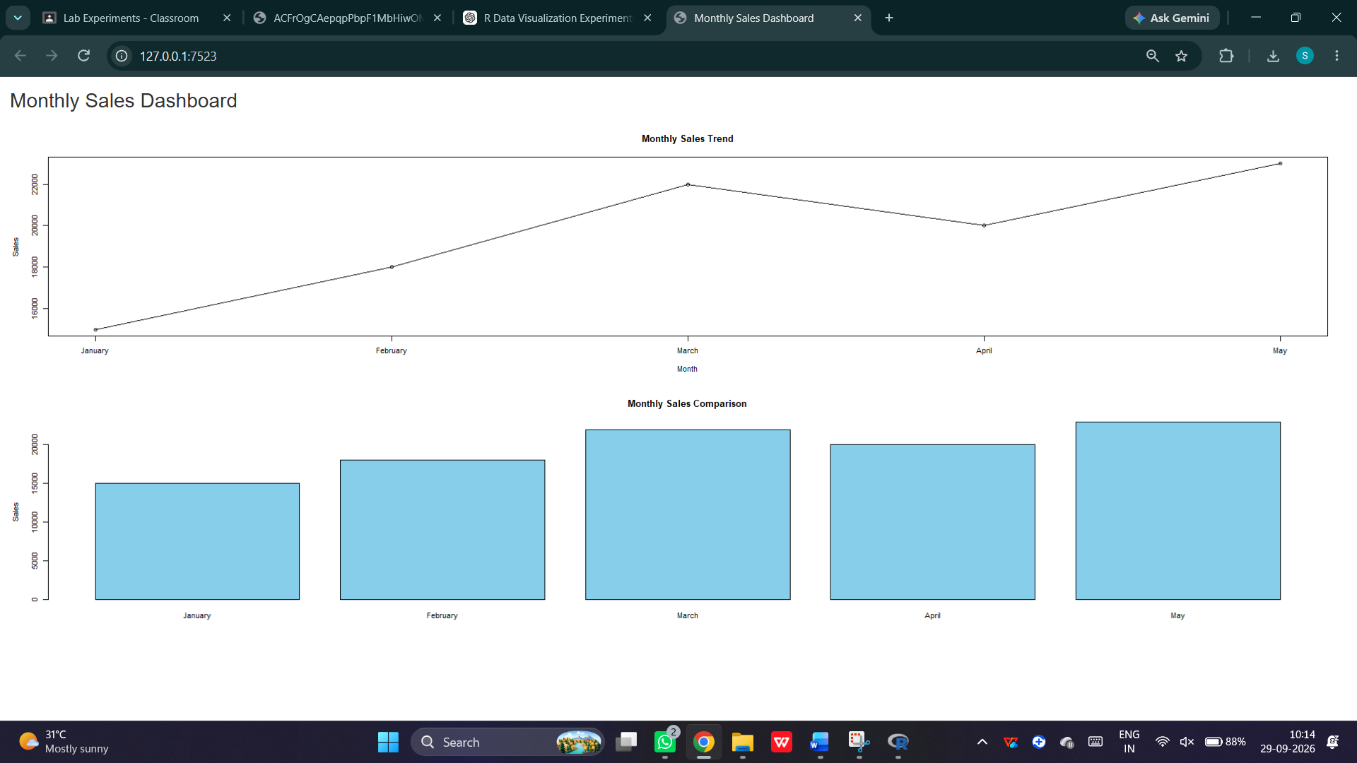

The dashboard displays:
- Monthly sales line chart.
- Monthly sales bar chart.
- Comparison of sales across five months.
Result
Thus, an interactive sales dashboard combining line and bar charts was developed using R Shiny.

Experiment 5: Histogram for Customer Age Distribution
R Programming
Aim
To create a histogram using R to represent the distribution of customer ages with proper title and axis labels.
Dataset: Customer Satisfaction
Customer ID | Age | Satisfaction Score
1 | 25 | 4
2 | 30 | 5
3 | 35 | 3
4 | 28 | 4
5 | 40 | 5
Algorithm
- Start the program.
- Create a dataset containing customer ages.
- Store the age values in a variable.
- Use the hist() function to create a histogram.
- Add title and axis labels.
- Set the histogram color.
- Display the histogram.
R Program
age <- c(25, 30, 35, 28, 40)
hist(age,
col = "skyblue",
main = "Customer Age Distribution",
xlab = "Customer Age",
ylab = "Frequency",
border = "black")
grid()
Sample Input
Customer Ages:
25, 30, 35, 28, 40
Sample Output
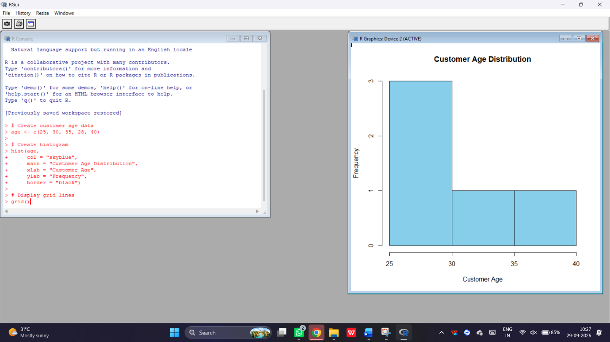
Expected observation:
- Minimum age = 25 years.
- Maximum age = 40 years.
- The histogram displays the frequency distribution of customer ages.
Result: Thus, the histogram representing the distribution of customer ages was successfully created using R.

